# ISLAMIC UNIVERSITY OF TECHNOLOGY

# PHYSICS LAB REPORT

# Experiment No. 10 Group/Batch No.: 03

# Student No.:

# Course Number: 4142

# Name of the Experiment:

# DETERMINATION OF THE RADIUS OF CRUVATURE OF A CONVEX LENS AND THE REFRACTIVE INDEX OF THE MATERIAL OF THE LENS BY BOY’S METHOD

# Date of Performance: 14 February, 2019 Name:

# Date of Submission: 14 February, 2019 Department: C.S.E.

# Section:

Partner’s ID No.:

Theory:

The focal length of a lens is given by:

- (i)

where $μ$ is the refractive index of the lens’s material and $r_{1}$ and $r_{2}$ are the radii of curvature of the two surfaces of the lens.

For a double convex lens, $F$ and $r_{1}$ are positive, but $r_{2}$ is negative, so the equation becomes:

- (ii)

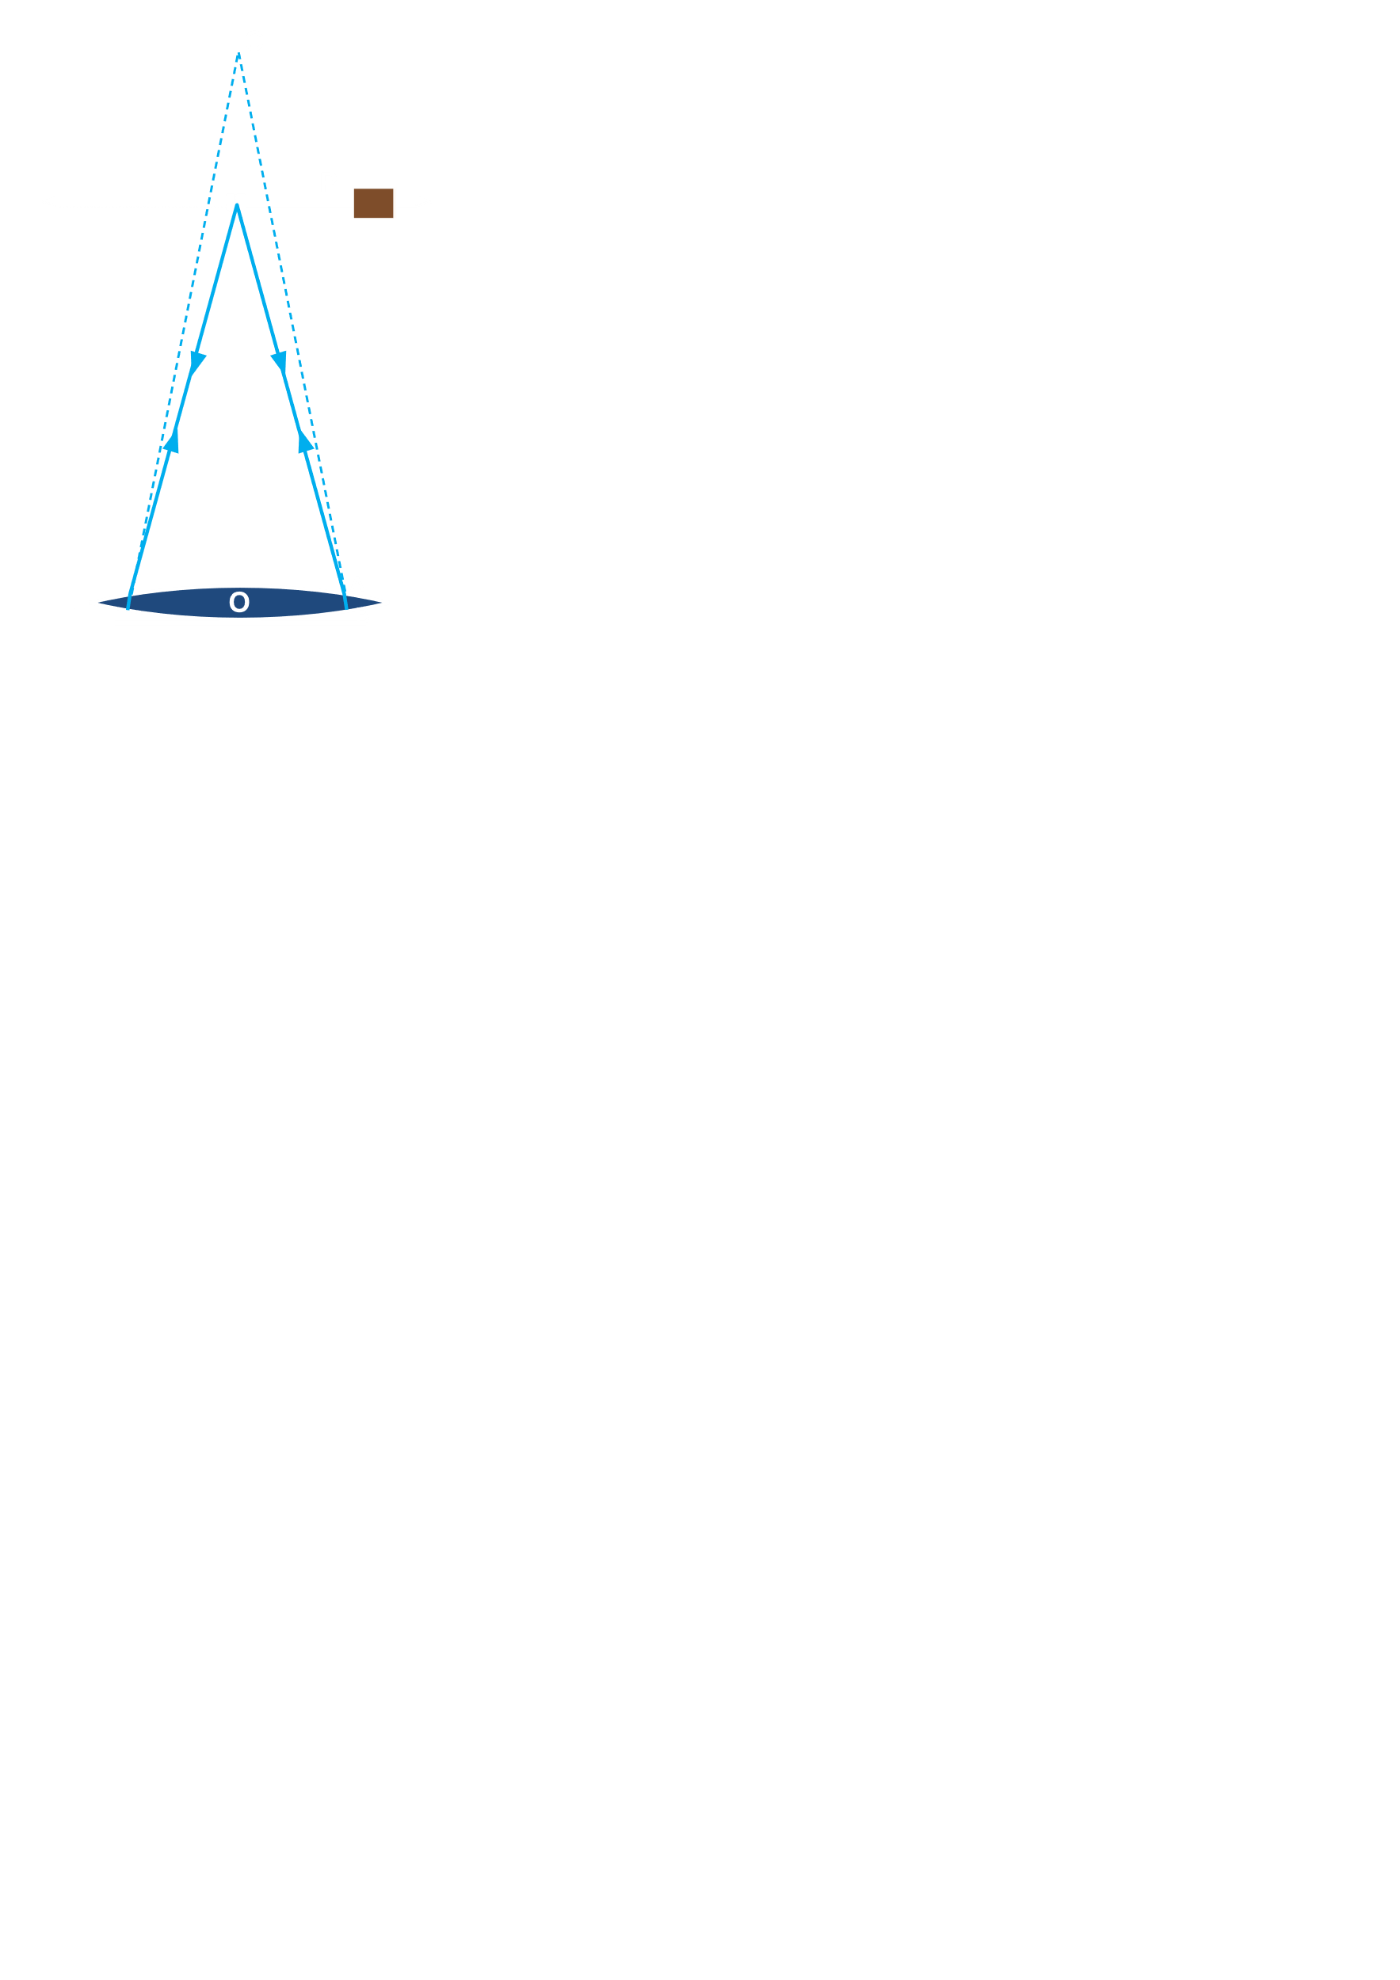

The figure shows the setup. A pin, $P_{1}$, is held so that its tip lies on the same axis as the centre, $C$, of the lens. Two images will form, one that is erect and is formed due to reflection at the front surface of the lens, and one that is inverted and is formed by reflection from the back surface. At a certain position of $P$, this inverted image will form by its side, proving that the refracted ray is incident normally on the concave surface. Extended backwards, this refracted ray cuts the vertical axis at $C$, making the ray appear to be produced at $C$ when looked at through the lens. The image of $P$ will appear at $C$. If $OP=d_{1}$ and $OC=r_{2}$,

$$\frac{1}{v}-\frac{1}{u}=\frac{1}{F}$$

According to sign convention, $v$ and $u$ are negative, so

$$\frac{1}{v}=\frac{1}{u}-\frac{1}{F}$$

Since $u=d_{1}$ and $v=r_{2}$, we get

- (iii)

Similarly, after flipping the lens,

- (iv)

Substituting equations (iii) and (iv) into equation (ii),

- (v)

Rearranging equation (v), we get

- (vi)

Thus, if $d_{1}$, $d_{2}$ and $F$ can be determined, $μ$ can be calculated.

Apparatus:

Convex Lens, Dish, Mercury, Pin, Plane Mirror, Scale

Procedure:

1. The lens was placed on a plane mirror and the pin, $P$, held above it. At a certain height, the image of the pin was formed just beside it and the size of the image was the same as the object. At this position, the distance between the top of the lens and the pin, $h$, was measured. Multiple readings of $h$ were taken. Slide callipers were then used to measure the thickness of the lens, $t$. The focal length, $F$, for each value of $h$ was calculated using the equation $F=h+\frac{t}{3}$. The mean value of $F$ was taken for calculations.
2. The lens was then placed on a dish full of mercury. In a manner similar to step (i), a pin was held above the lens. At a certain height, the inverted image of the pin was coincident with $P$. The distance, $h_{1}$, from the top of the lens to the pin was measured.
3. The lens was flipped and step (ii) was repeated to find $h_{2}$

$d_{1}$ ($d_{1}=h_{1}+\frac{t}{3}$) and $d_{2}$ ($d_{2}=h_{2}+\frac{t}{3}$) can now be calculated.

Data Collection:

Thickness ($t$) of the lens:

|  |  |  |  |  |  |  |
| --- | --- | --- | --- | --- | --- | --- |
| Obs. No. | Main Scale Reading  ($A$) | Vernier Scale Divisions  ($N$) | Least Count  (L.C.) | Fractional Reading $$F=\left(N×L.C.\right)$$ | Total $$T=F+A$$ | Mean $$\frac{\sum{T}}{N}$$ |
|  | $$cm$$ |  | $$cm$$ | $$cm$$ | $$cm$$ | $$cm$$ |
| 01 |  |  |  |  |  |  |
| 02 |  |  |  |  |
| 03 |  |  |  |  |

Data for calculation of focal length:

|  |  |  |  |
| --- | --- | --- | --- |
| Obs. No. | Distance between pin and top of lens  ($h_{1}$) | Focal Length $$F=h+\frac{t}{3}$$ | Mean $$F$$ |
|  | $$cm$$ | $$cm$$ | $$cm$$ |
| 01 |  |  |  |
| 02 |  |  |
| 03 |  |  |

Data for calculation of $d_{1}$ and $d_{2}$:

|  |  |  |  |  |  |  |
| --- | --- | --- | --- | --- | --- | --- |
| Obs. No. | Distance between pin and first surface of lens, when on mercury  ($h_{1}$) | $$d_{1}=h_{1}+\frac{t}{3}$$ | M  E  A  N $$d_{1}$$ | Distance between pin and second surface of lens, when on mercury  ($h_{2}$) | $$d_{2}=h_{2}+\frac{t}{3}$$ | M  E  A  N $$d_{2}$$ |
|  | $$cm$$ | $$cm$$ | $$cm$$ | $$cm$$ | $$cm$$ | $$cm$$ |
| 01 |  |  |  |  |  |  |
| 02 |  |  |  |  |
| 03 |  |  |  |  |

Calculation:

$$μ=1+\frac{d_{1}d_{2}}{d_{2}F+d_{1}F-2d_{1}d_{2}}$$

$$=$$

$$r_{1}=\frac{Fd_{2}}{F-d_{2}}$$

$=$ $cm$

$$r_{2}=\frac{Fd_{1}}{F-d_{1}}$$

$=$ $cm$

Discussions:

1. Determining the focal length by pin method was difficult since the equality in size of the object and image must be done by eye. This is likely to have caused large parallax errors.
2. Multiple readings were taken at every step and average values used in calculations to try and reduce the effect of human errors.